Chapter 19, Problem 46.

Find the transmission parameters for the circuit in Fig.19.101.
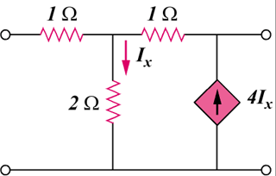

2 Ω

1 Ω

1 Ω

I_{x}

4I_{x}

Figure 19.101
For Prob. 19.46.

